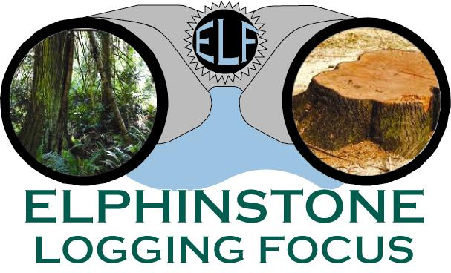

PRESS RELEASE
September 3rd, 2019

BC Timber Sales Preparing Dakota Valley for Extensive Old-Growth Logging

The BC government, through its logging agency BC Timber Sales (BCTS), is reopening a logging road leading into the Dakota Valley (Sunshine Coast) for a major old-growth logging operation. The valley has had a moratorium in place to help it recover from intensive past logging, but is now faced with losing 143 ha of intact old-growth. The blocks include A92904, A87126 and TA0044 and could be sold in 2020. The valley is within the traditional lands of the Squamish Nation.

Dakota Creek, located west of Port Mellon, is a designated community watershed under the Forest and Range Practices Act (FRPA). It became a community watershed in 1995 when the Sunshine Coast Regional District (SCRD) gained a water license on the creek. They applied for this watershed status to protect the creek from sediment sources caused by landslides that could be triggered by industrial activities. The SCRD intends this watershed will provide potable drinking water to the Langdale area to support planned growth.

In the 1950s and 1960s, clearcutting of the yellow and red cedar took place in the lower and mid elevations across this 3,361 ha watershed. Canfor was the last operator in the valley when in 2000 it was determined that the watershed was hydrologically unstable due to several landslides occurring in the steep walled valley leading to a moratorium on further logging. BCTS is now proposing cutting up to 143 ha of old-growth claiming that the watershed is now hydrological stable.

“The Sunshine Coast Regional District has consistently opposed logging in the Dakota Community Watershed beginning in 2013 when these blocks were first referred to the Board by BCTS.” states Ross Muirhead, Forest Campaigner for ELF. “In October 2014, the bridge that passes over Dakota Creek along the Port Mellon Hwy was completely washed out by a raging Dakota Creek. Three times in 2016 the creek damaged the bridge and on Nov. 22nd, floodwaters came close to spilling right over the bridge. This should tell Planners that the watershed is still prone to flash flood conditions that negatively affects the creek’s ability to maintain stable salmon habitat and provide clean drinking water when the system comes online.”

“A report, paid for by BCTS, looked at climate change models for Dakota Watershed predicting that in 60+ years this valley could see autumn rainfall increase of 17-36% and winter increases of 4% to 28%. These extreme, wetter conditions do not bode well for protecting water quality in a watershed with historic stability issues” adds Hans Penner of ELF. “The NDP seems hell bent on logging the last of the magnificent old-growth stands across Vancouver Island and the Sunshine Coast. Just when the entire planet needs to be protecting forest diversity for a host of environmental reasons - Victoria is going in the opposite direction.”

A copy of the Statlu Environmental Consulting report can be viewed here:
BCTS planned blocks in the Dakota Community Watershed can be viewed here:
A few photos of the new roadbuilding are seen below along with increased bank support of Dakota Creek in anticipation of future flash flooding.

