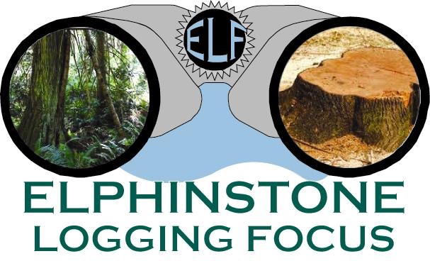
www.loggingfocus.org

AJB/SURESPAN LOGGING CONTINUES IN THE CHAPMAN DRINKING WATERSHED
July 6, 2018

AJB Investments (Surespan, North Vancouver) is completing logging on the west side of the Chapman Creek Watershed in a block the company walked away from in 2014. One third of the block was left when Surespan agreed to stop logging due to public concerns that resulted in a roadblock. The affected forest is approximately 1km above the Sunshine Coast Regional District’s (SCRD) water intake. In May, ELF collected drone footage showing extensive logging close to the Chapman Creek and on steep slopes.

AJB owns up to 160 Ha (400 acres) of private lands within the Chapman Creek Drinking watershed that the Sunshine Coast Regional District draws water from as the official water purveyor. The value of the lands before being logged was estimated at $7 million.

“Drone footage obtained shows in one section tree cutting coming very close to the Chapman Creek with no trees left above on steep slopes,” Ross Muirhead of ELF states. “Riparian Tree Retention guidelines set by the Managed Forest Council (MFC) states that a minimum of 30 trees be retained along a 100M stretch of river. The set back is 30M divided into 3 x 10M bands. In one section of river it appears no trees were left in the 2nd band and none in the 3rd band. MFC states that trees can only be cut in the 3rd band if no ‘material adverse effect’, such as soil erosion, can be adverted. In our estimation, all trees should have been left in the full 30M setback since logging was occurring in a sensitive community drinking watershed. We issued a complaint to MFC on this matter which seems to be ongoing.”

“It is painful to watch, even at a distance, trees being cut down in the watershed, that we thought had been saved in the fall of 2014. It is also shocking to see all the now clear-cut areas of forest on both sides of Chapman Creek that would still be protected if the private property in the watershed had been purchased,” says Hans Penner also of ELF.

“It’s frustrating when those in charge of the public’s drinking water don’t understand the necessity of protecting the source of our water. As stated in the introduction to Plants of Coastal British Columbia by Polar and Mackinnon: ‘Forests are now recognized as critical for maintaining water supply for many communities in our region.’”

