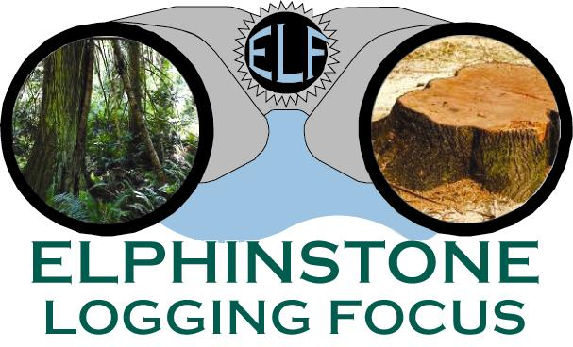
www.loggingfocus.org

Press Release
May 28, 2019

Clack Creek Forest Sold at a Suspiciously Low Price

The Clack Creek Gallery Forest (BC Timber Sales Blk A93884) was sold on April 30, 2019 to Squamish based Black Mount Logging Ltd. ELF examined this auction and compared it to other BCTS blocks sold in the region leading to serious questions about the legitimacy of this sale.

The BCTS program has 20% of the provincial timber land base allocated to it. Timber is sold through an auction-based model to determine market pricing of this natural public resource. The combined amount from BCTS ‘Upset Price’ (the minimal value they’re prepared to sell a block of timber for), plus the ‘Bonus Bid’ (what a contractor is prepared to pay for the timber over and above the Upset Price) is the amount Crown receives for a timber sale. Contractors set their Bonus Bid based on current and/or future log market prices, plus operating costs. BCTS uses this ‘free-market’ process to determine the stumpage tax applied on other licensees logging Crown timber.

“The auction model was chosen by BCTS to determine the best price for timber based on the rationale that having multiple contractors engage in a competitive bidding process results in a price driven by the market.” states Ross Muirhead, a forest campaigner with ELF. “However, the Clack Creek Forest block received only one bid, the one from Black Mount Logging. All other blocks we looked at received 6-10 bidders. In a review of several BCTS sales from 2017-2019 there were no other sales awarded with only one bid accepted by the Timber Sales Manager and interestingly, Black Mount’s Bonus Bid of $161,222 was the lowest one noted. It’s reasonable to ask if their bid was suspiciously low because the word-on-the street amongst contractors was that no one else was going to bid on this contentious block, so go low and it’s yours.”

“We compared two BCTS blocks sold in the area and found that the Bonus Bid on a West Sechelt block was $1.42M and a Bonus Bid on a block east of the B&K Rd was $602,692. The timber volume for all 3 blocks was approx. 28,000 cubic metres, although in our estimation the Clack Creek Forest, with 76% mature Douglas-fir, has the higher quality wood.” remarks Hans Penner also of ELF. “This block should not have been sold in the first place before the Elphinstone Modern Land Use Plan was completed, but the further insult is the low value the province is prepared to accept for this fantastic forest. It appears that a subsidy is being handed out to get a nasty job done that no local contractors wanted to touch.”

For further information contact:
Ross Muirhead, Forest Protection Campaigner
604-740-5654

